**Tableau Prep Project on VideoGame Sales**

Submitted in partial fulfillment of the requirement

for the award of the Advanced Diploma of

**DATA SCIENCE AND APPLICATION**

Of

**METRO COLLEGE OF TECHNOLOGY**

**2020-2021**

Submitted to

**Prof.Hamid Rajaee**

Submitted by

**Mr. Sajith Vellappillil**



**About Dataset**

VideoGames Sales

Source: Kaggle

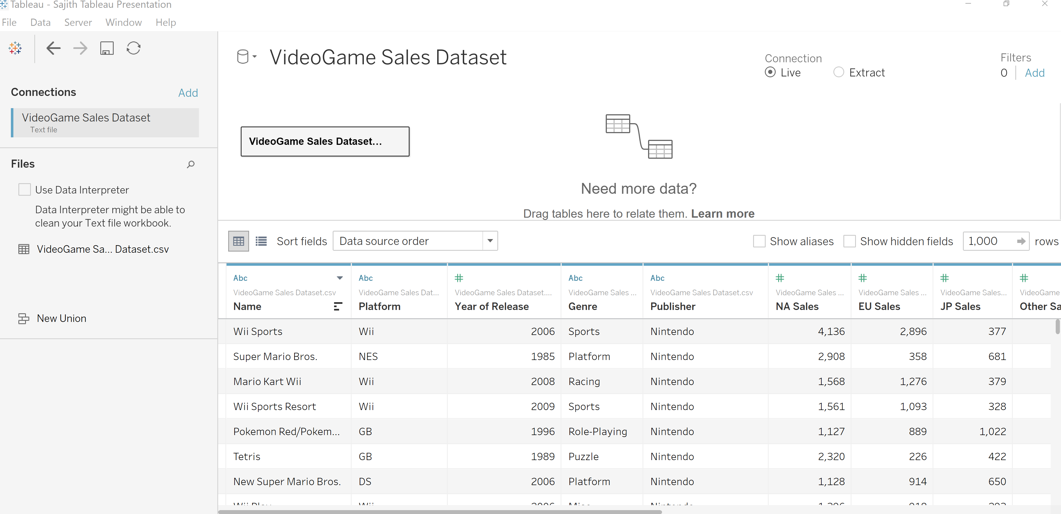

**Business Questions**

1. Which are the top 5 publishers?

2. Which is the top videogame for each region and Sales for the top seller game?

3. Which is the best and the worst gaming platform?

4. Which is the best selling Genre for top 5 platforms?

5. Which games are top user picks?

* **Top 5 Publishers**

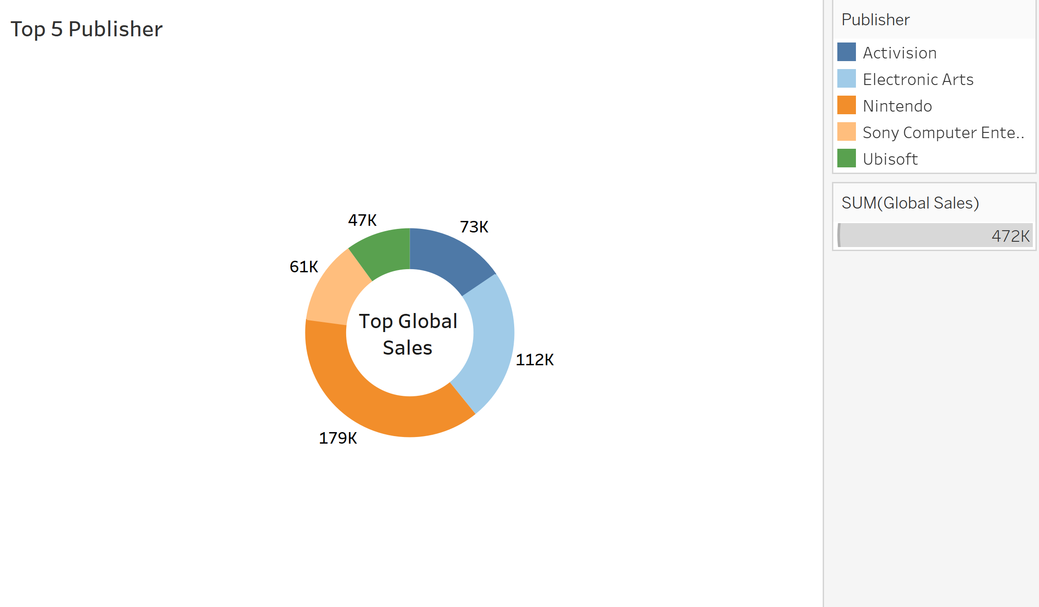

Interpretation

The top 5 Publishers are:

Nintendo - $179K

Electronic Arts – $112K

Activision - $73K

Sony Computer - $61K

Ubisoft – 47K

* **Top Videogame for each Sales region:**

Interpretation

In the North American region, Wii Sports with a total sales of 4136 is the top selling video game.

In Japan, Pokemon Red/Pokemon Blue with a total sales of 1022 is the top selling video game.

In Europe, Wii Sports with a total sales of 2896 is the top selling video game.

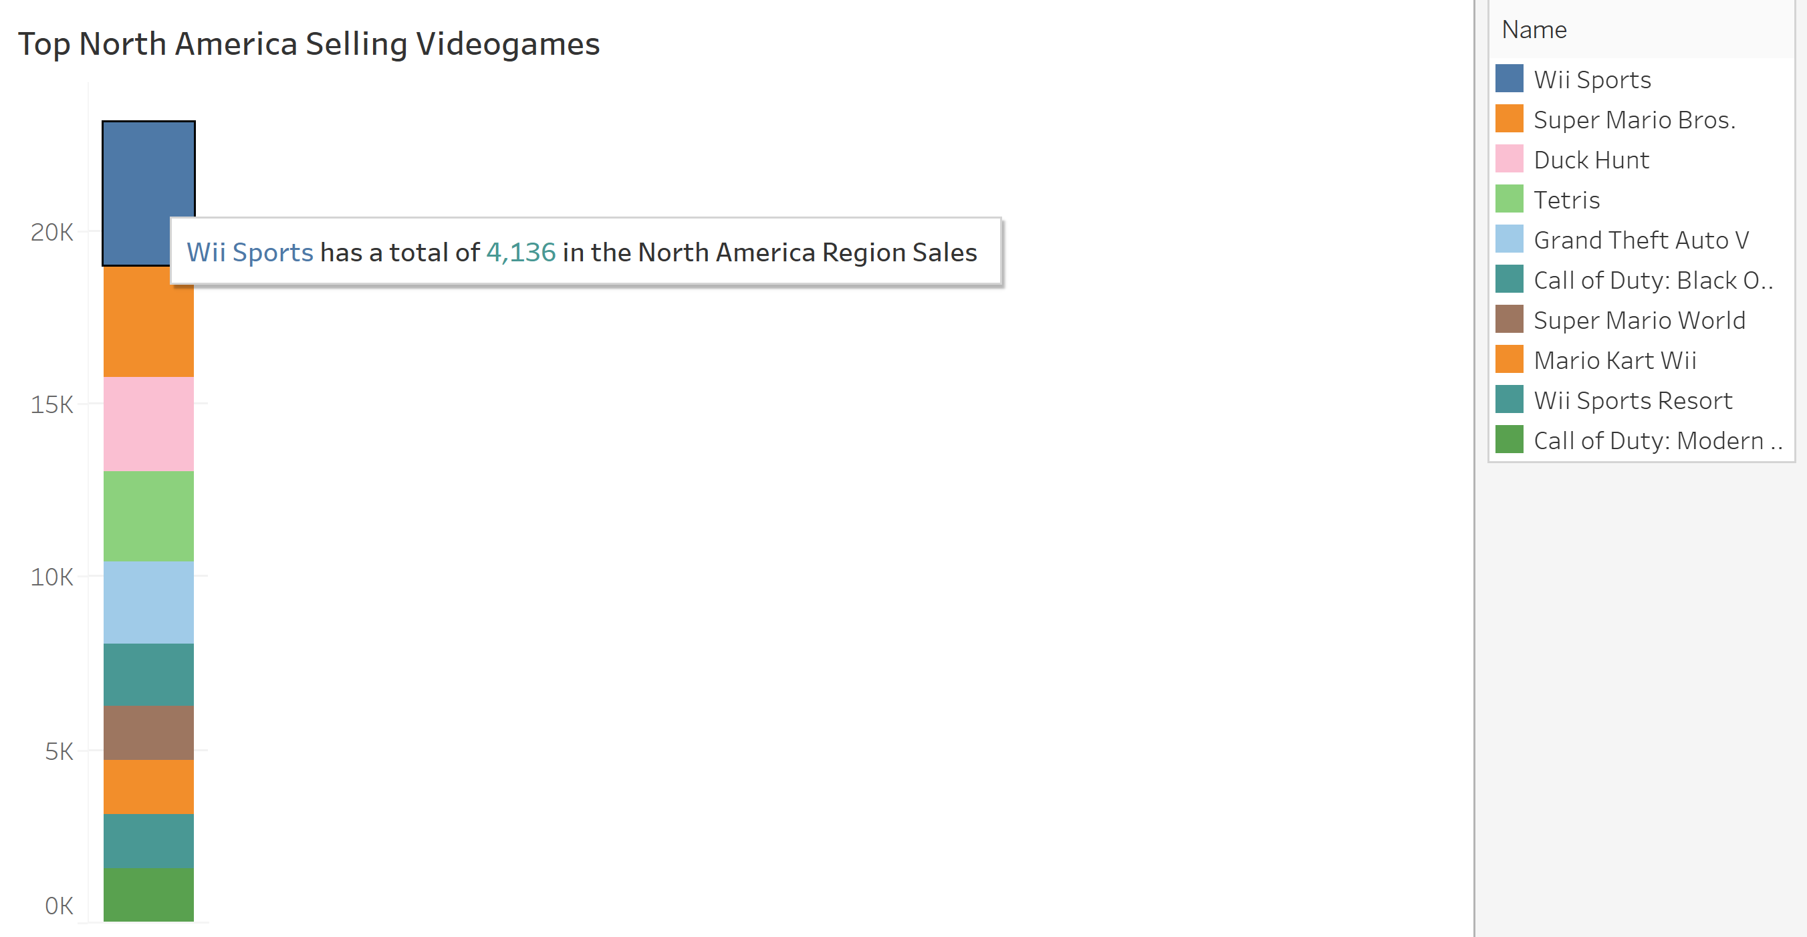

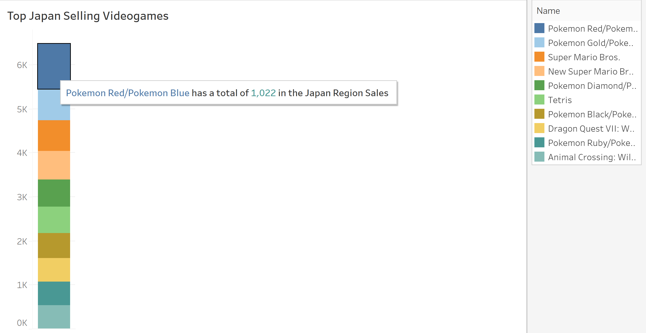

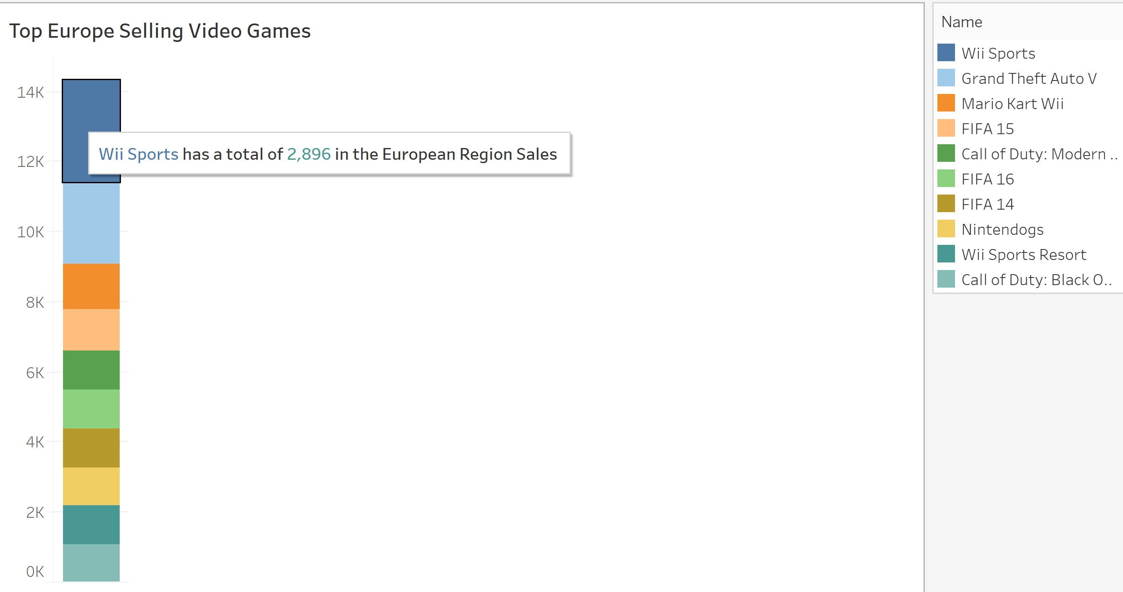

* **Best and Worst Gaming Platform**

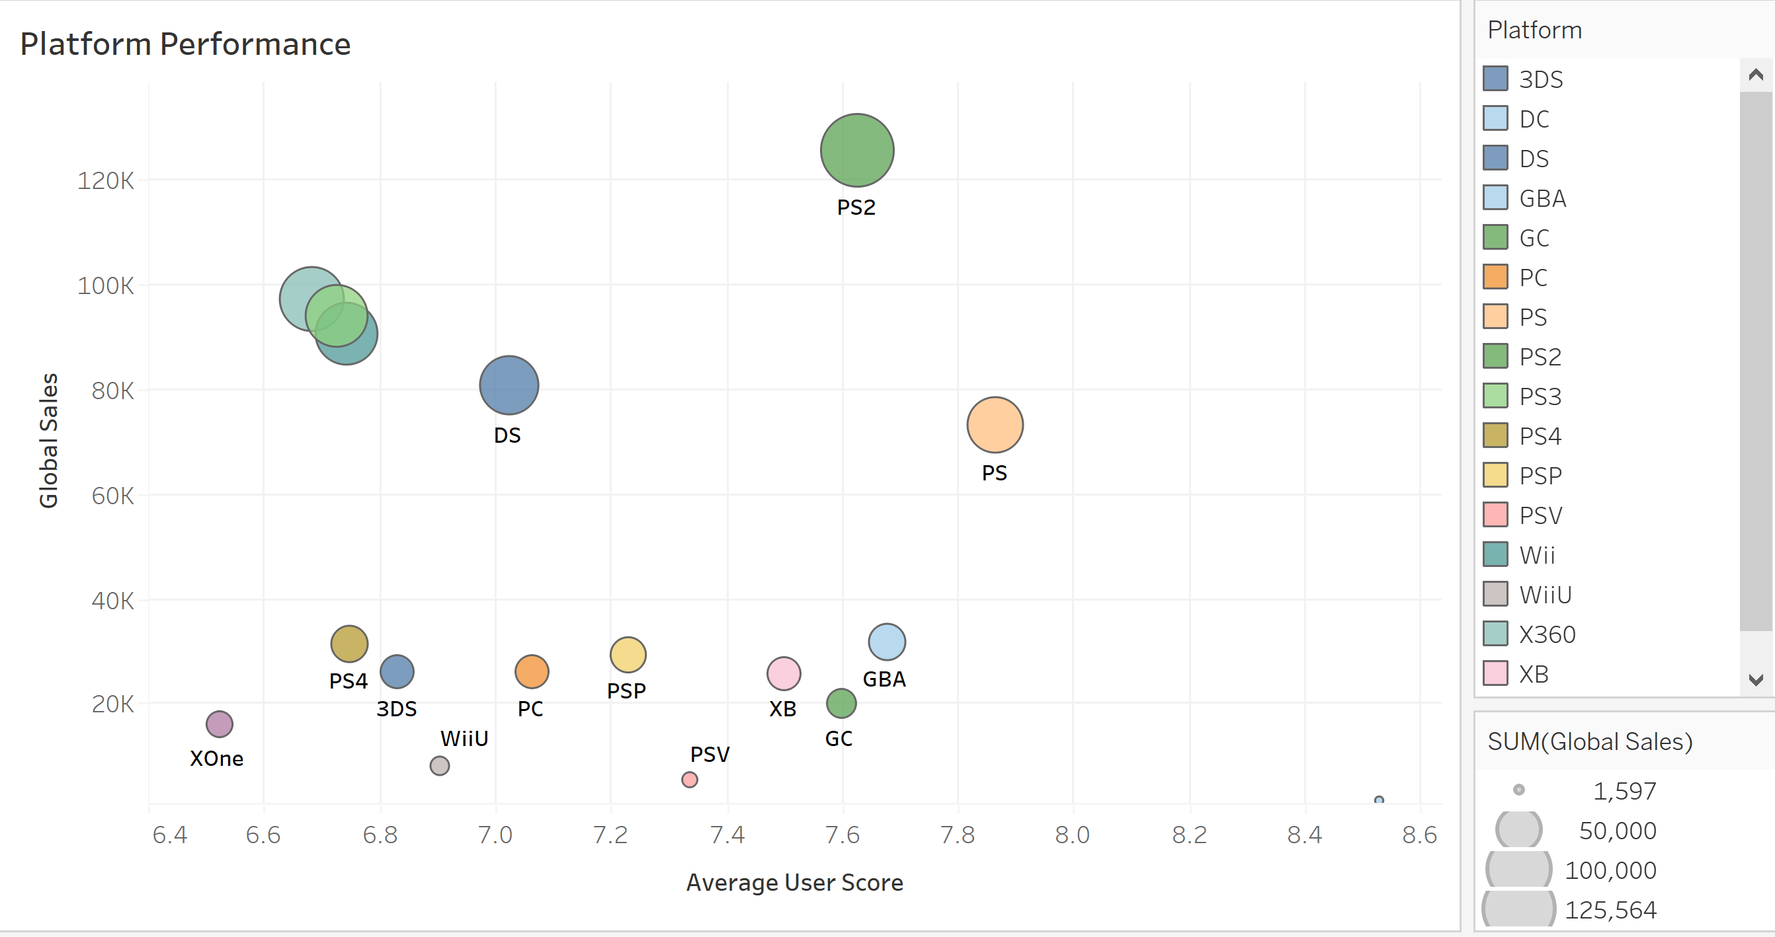

Interpretation

The best gaming platform in regards to top global sales is PS2 with sales crossing 120K, however, PS has the higher user score between 7.8 to 8

The worst gaming platform in terms of sales as well as user score is Xone.

* **Top Genres for top platforms**

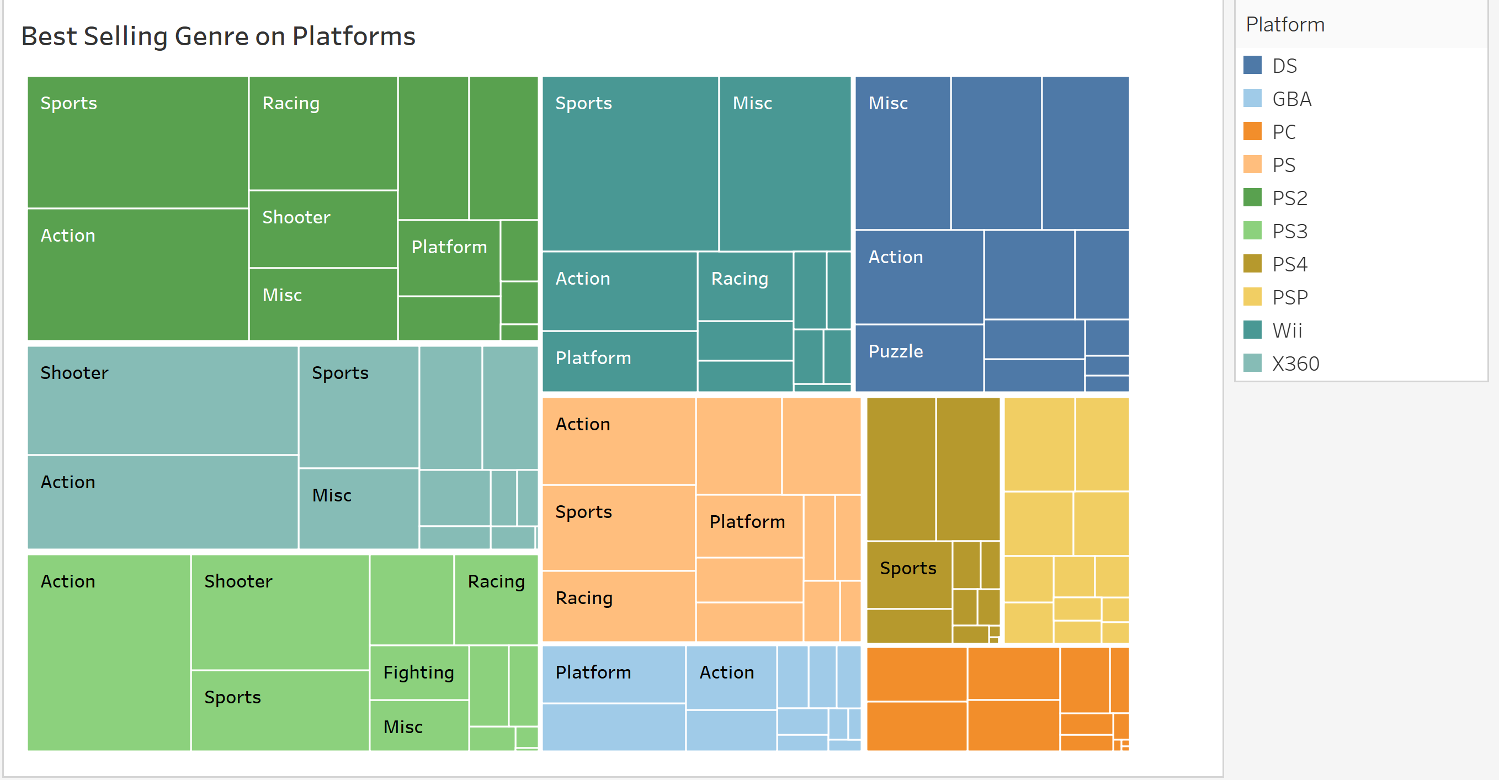

Intepretation

We see that Sports, Action, Shooter and Racing are the popular genres among the top platforms.

* **Top User Picks**

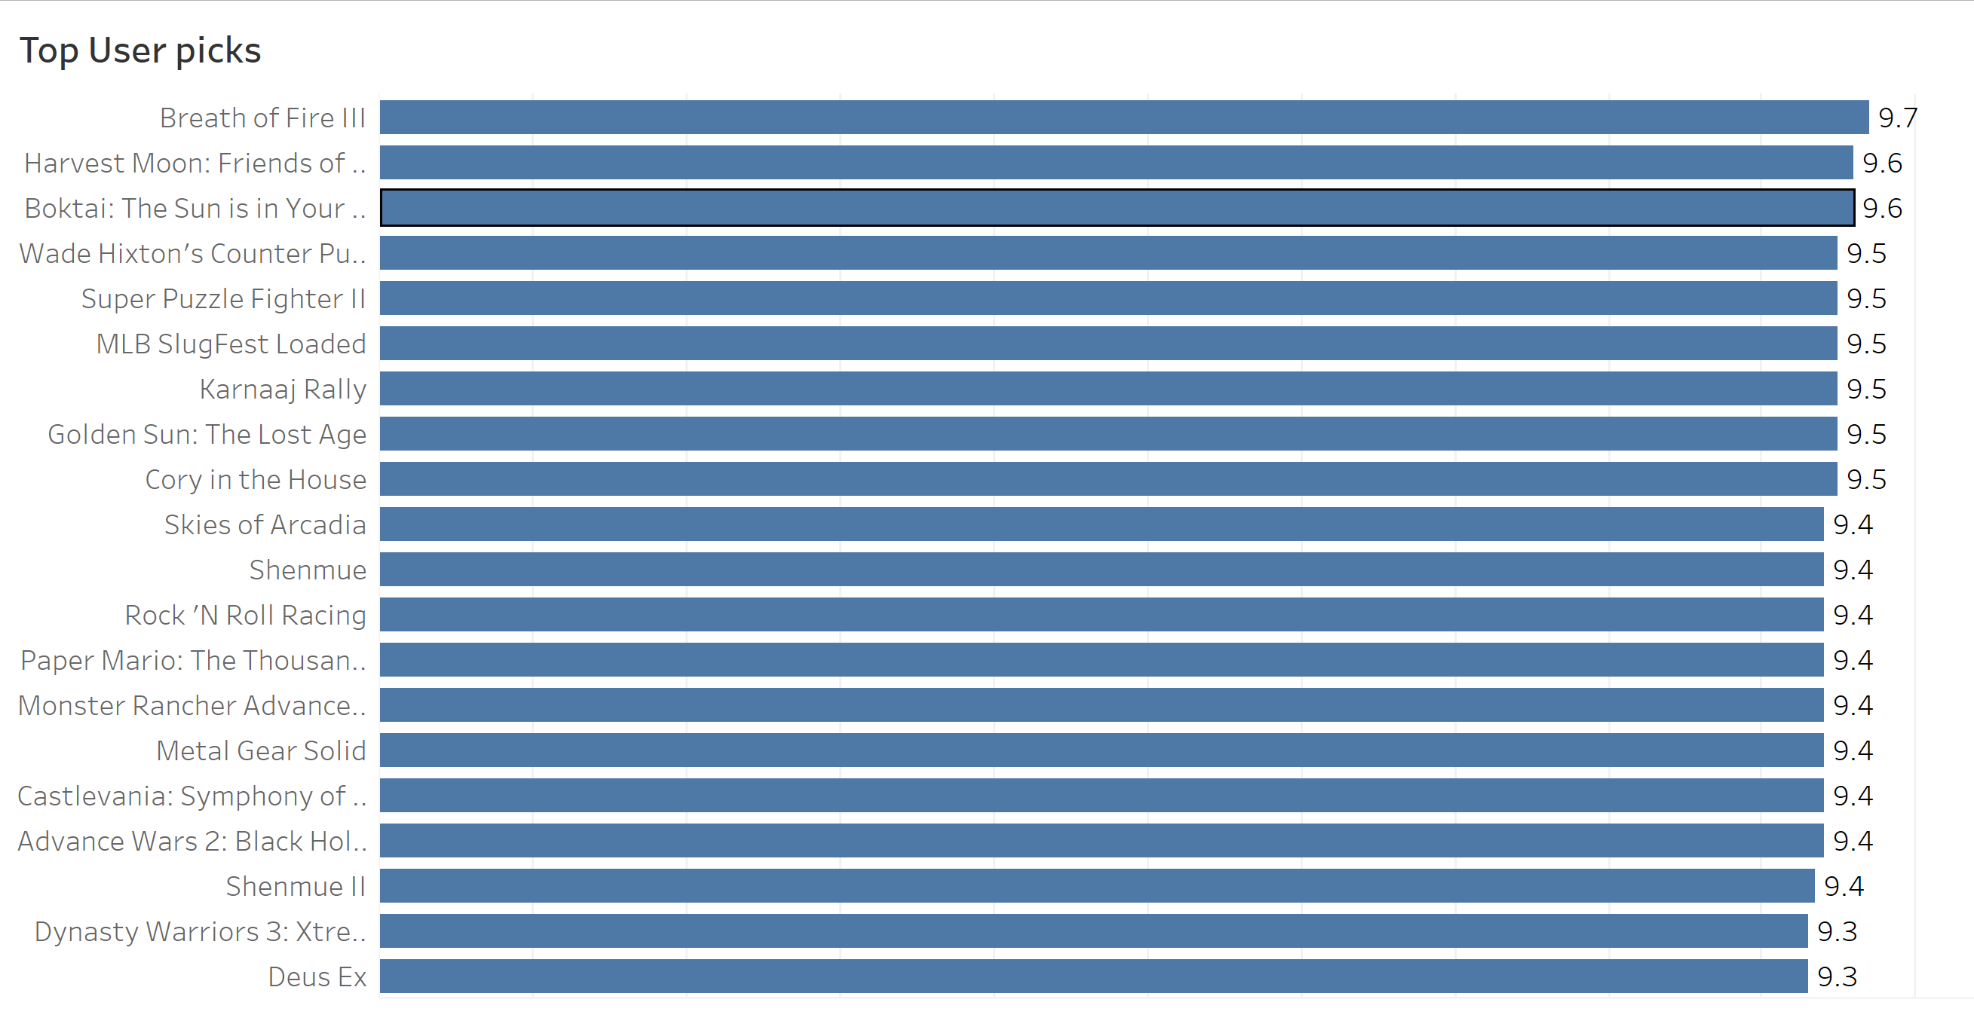

Intepretation

The top user pick game is Breath of Fire III with the highest rating of 9.7

**VideoGame Sales Dashboard**

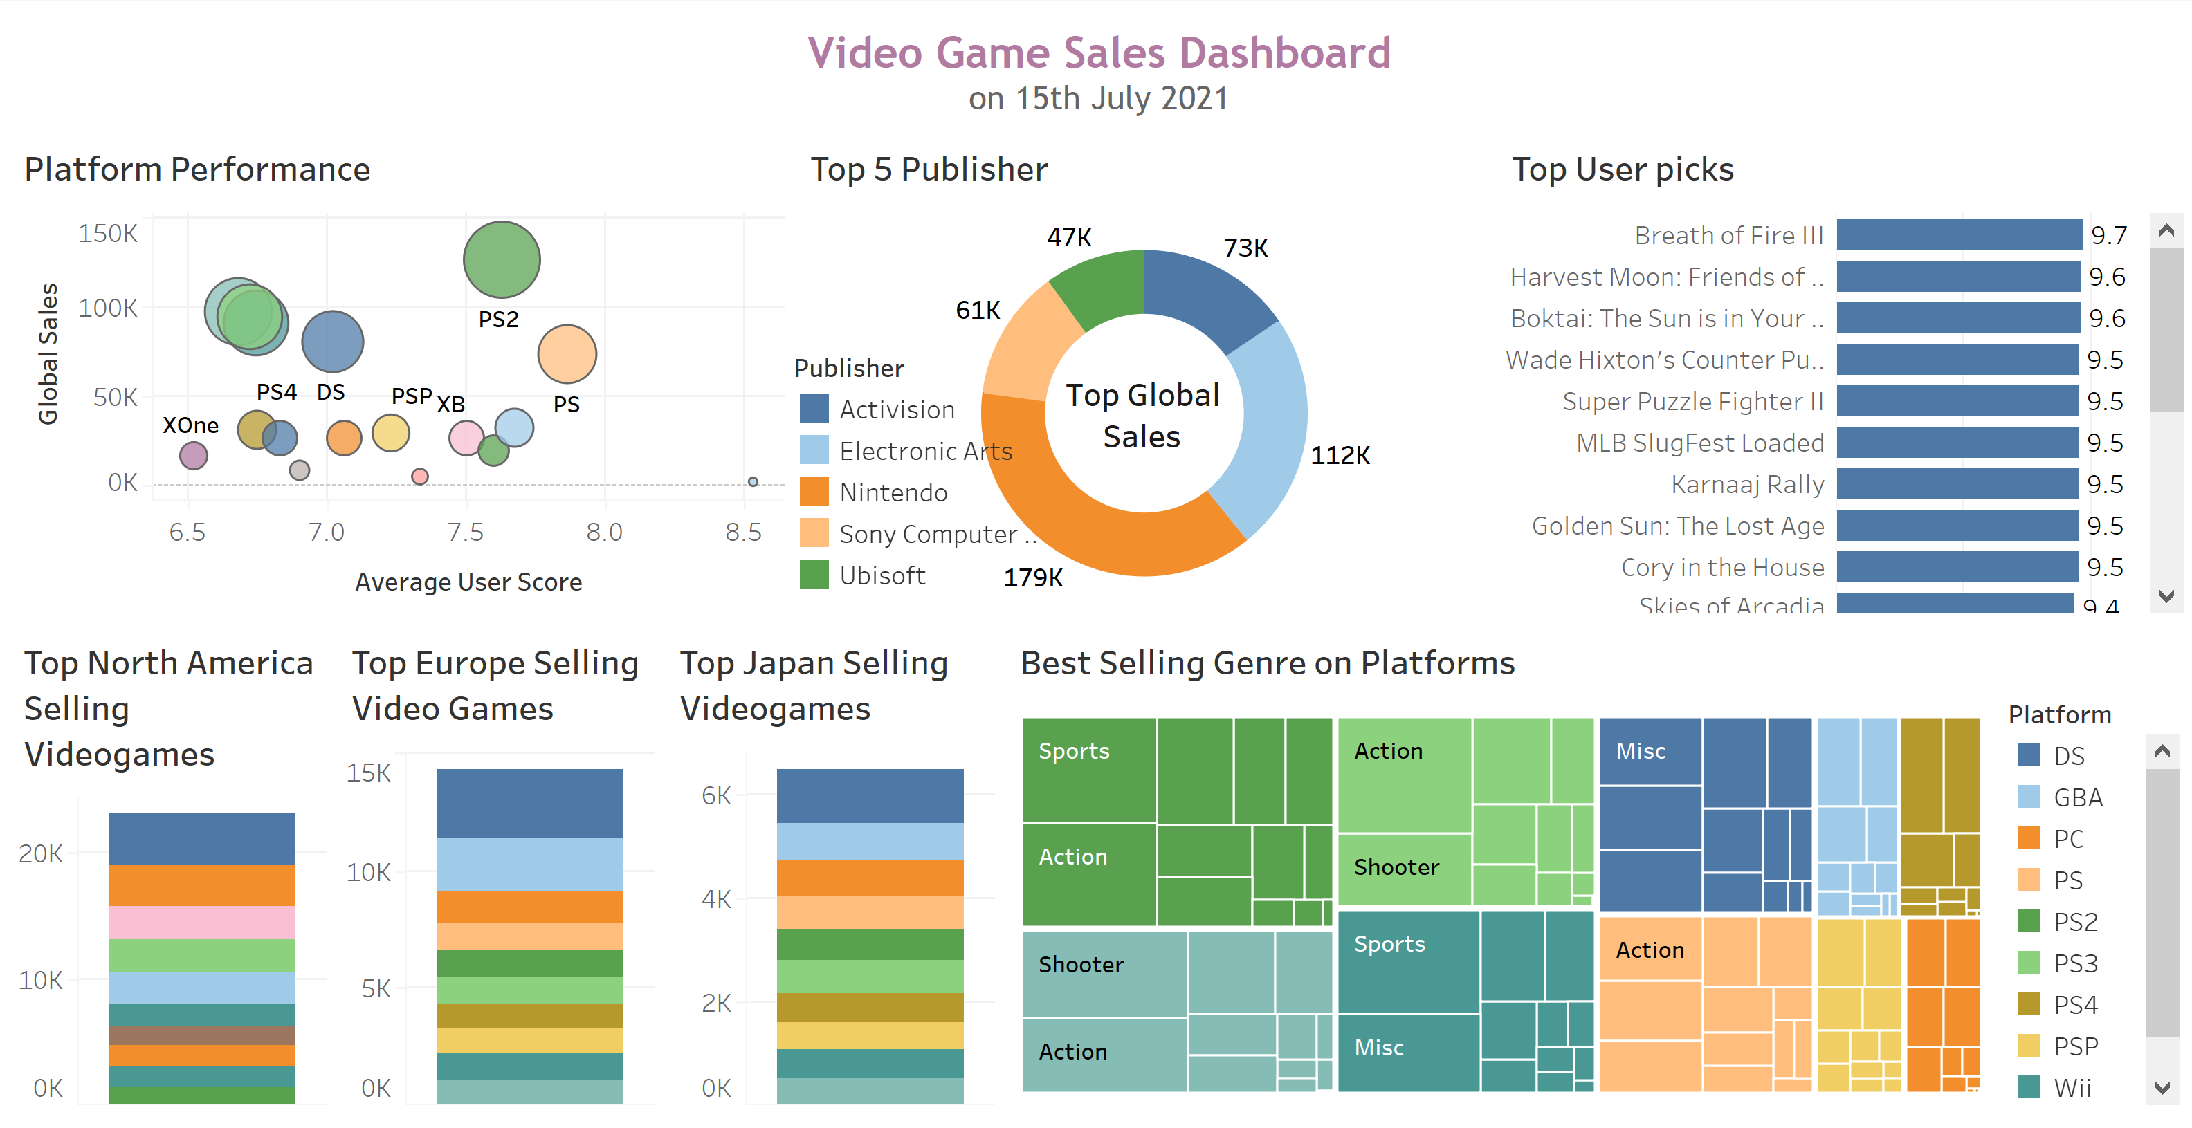

**Story**

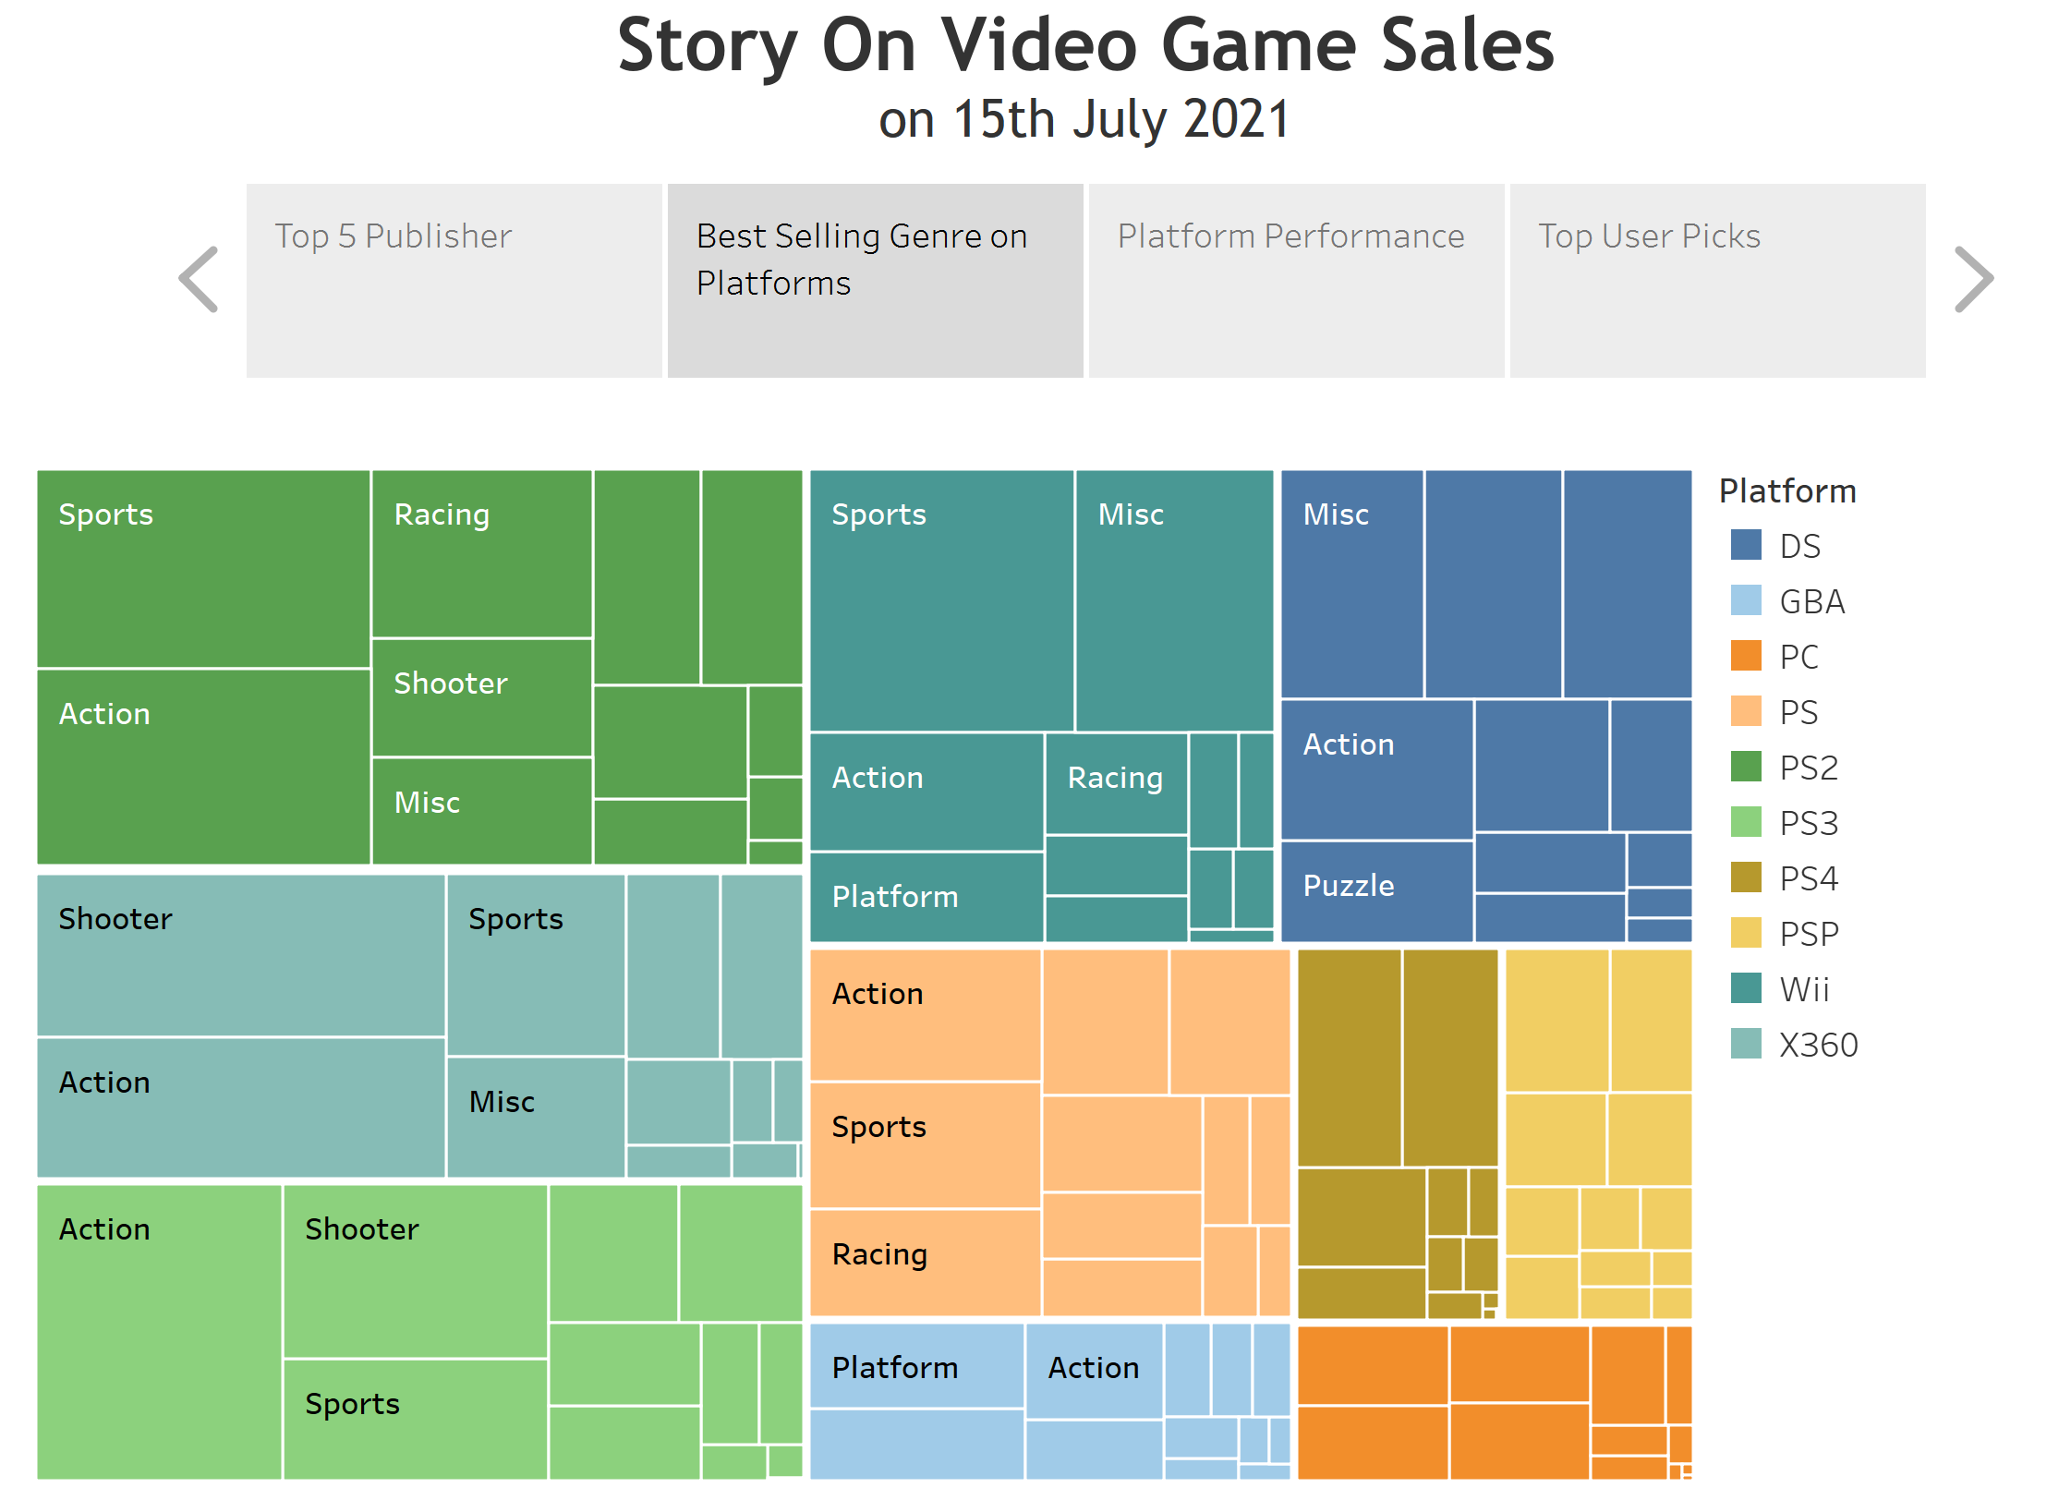

**Conclusion**

* Top 5 Publishers:

Ninetendo

Electronic Arts

Activision

Sony Computer

Ubisoft

* Top selling Videogame:

North America : Wii Sports

Japan: Pokemon Red/Pokemon Blue

Europe: Wii Sports

* Best Platform: PS , however top sales are on PS2

Worst Platform: Xone and has the lowest sales

* Best selling Genre on best platform PS2: Sports and action. Other popular genres are Shooter and Racing
* Highest Selling Genre: Action
* Top User Pick: Breath of Fire III